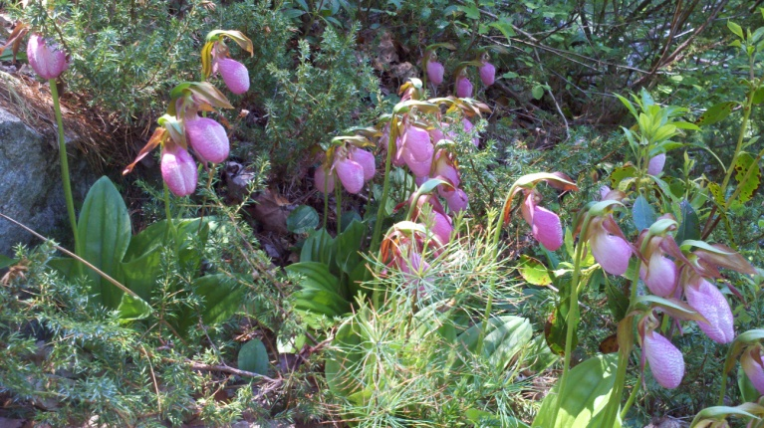
Lady Slippers at the Mason Quarry 2014
Remembering Ginny Rafter’s love of flowers

Wendell Berry, The Art of the Commonplace: The Agrarian Essays, 21st century
"I don't think it is enough appreciated how much an outdoor book the Bible is. It is a 'hypaethral book,' such as Thoreau talked about--a book open to the sky. It is best read and understood outdoors, and the farther outdoors the better. Or that has been my experience of it. Passages that within walls seem improbable or incredible, outdoors seem merely natural. This is because outdoors we are confronted everywhere with wonders; we see that the miraculous is not extraordinary but the common mode of existence. It is our daily bread."
Save the Date:
- Father’s Day June 15 Giving thanks for all our fathers.
- June 12 Community Supper Thank you to our fine Mason Fire Department volunteers who were tthe hosts for this dinner. They made fires for the Bar-B-Q burgers!
- June 21 Coffee House at Mason Church 7:15 to the last song! Don’t miss the last Coffee House until September.
- July 10 Community Supper 5:30 to 7pm A celebration of salads, including Chicken Salad, a shrimp salad, and others.
- July 10 Music after Community Supper! From 7:15 to 9ish. Bring a chair, and maybe some bug spray, and thank you to our musical talents in the community.
- July 20 at 2pm Doug Schimke’s Celebration of Life will be at Ellen’s with a service starting at 2pm, and food and memory sharing afterwards. Reverend Robert Vodra will perform the service of remembrances.
- Summer Bible School in August 14. 15. & 16. Jennie Walsh is organizing this and more information will be available soon. Spread the word, the theme is “Blast Off.”
- August 17, Sunday 10 am Brookline and Mason outdoor church service, with lots of music and merry making, and a pot luck coffee/lemonade hour afterwards.
Church Yard Sale in September for Old Home Days 2014. Do some closet/garage cleaning this summer and help out this fund raiser, and fun raiser. Some items can be stored at church. Call Betty at 878-2374 to discuss. Give books to the library for their sale, and remember that electronics should go to recycling, not the yard sale, thank you.

Search Committee News: The brochure and recruitment ad are on the NH United Church of Christ www.nhcucc.org website if you want to see them. We are receiving profiles from interested ministers, and will be reviewing these over the summer. No summer hammock lounging for the Search Committee.

Pie Auction: As usual it was successful. The old fashioned art of pie baking is alive and well at Mason Church, and the pie eaters are as devoted as ever. This fund raiser is always lively and a gustatory delight. Thank you to all bakers and bidders!

Knitters: Want to knit a prayer shawl? There is yarn at church for the knitting, and the pattern for shawls to wrap friends and loved ones with prayer & love. Prayer Shawls are not only a gift of love, the power comes in the knitting, see website: http://www.shawlministry.com/instructions.html
“The making of a prayer shawl is a spiritual practice which embodies our thoughts and prayers for the receiver. It is a gift freely given with no strings attached. Made in prayer, as prayer, for prayer, the shawls are passed on hand-to-hand and heart-to-heart…” Blessings, Janet and Vicky Email or call Susan Suokko if you have any questions. Usercat2@comcast.net or 941-920-0270 If you know of someone needing a prayer shawl, call Linda Lannin at 878-2470.

Mason Church Community Garden: The “Garden of Grace” has been planted and anyone is welcome to help weed, or pick. (Note: please do not harvest potatoes, Bill and Christine will be taking care of the potatoes.) Produce can go to church members, someone in need, or the food bank. If you plant your own garden, please think of the food bank and plant an extra row.

Make a note:
- Arthur Rafter is still recuperating from his fall last winter, but he is home now though not driving yet.
- Prayers for Gretchen as she continues to heal, and thanks to the many helping hands of church family and friends.
- Please continue prayers for the Schimke family.
- Thank you to all the food elves who are helping keep the food bin full. Remember to buy extra cereal, peanut butter, and canned fruits to help fill hungry bellies.
- Cans of Nothing: Over the summer the Food Bank has a special summer feeding program for children who normally receive free lunch at school. This is helpful for so many children who will receive a balance meal, at least once a day. Help us fill our cans of Nothing for this program.
- Help keep the coffee in our coffee hour… We use fair trade coffee, and support our coffee hour by selling coffee to you for your home use. Mason Church RUNS on FAIR TRADE coffee! Please contact Mark Stroms, 603 305-0023.
- We miss Laila at Sunday services but she is always in our thoughts. Send mail to Laila Washburn, c/o Brett Kivela, Will Road, New Ipswich 03071. Visitors are welcome, it would be good to call first. 878-3065
- Do you know someone who needs spiritual support or other support, of the pastor and deacons? Please call, your church family may be able to help. Leave a confidential message at 603-878-1684
Any news items, comments, or things you would like to share: email Michelle at miscott39@gmail.com or call 878-1680
Rachel Carson, 20th century "If I had the influence with the good fairy who is supposed to preside over the christening of all children I should ask that her gift to each child in the world would be a sense of wonder so indestructible that it would last throughout life, as an unfailing antidote against the boredom and disenchantments of later years, the sterile preoccupation with things that are artificial, the alienation from the sources of our strength."

